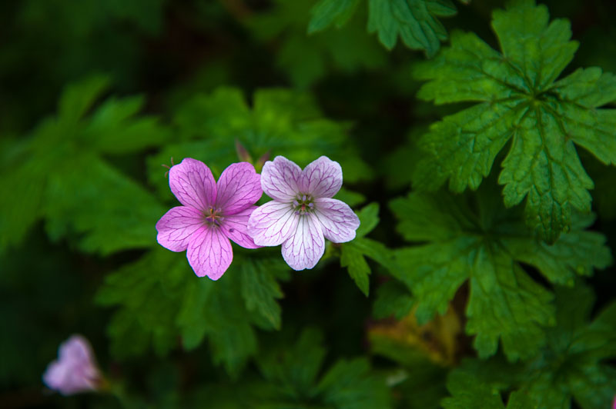
Original picture
Recolor effect (Sepia)

