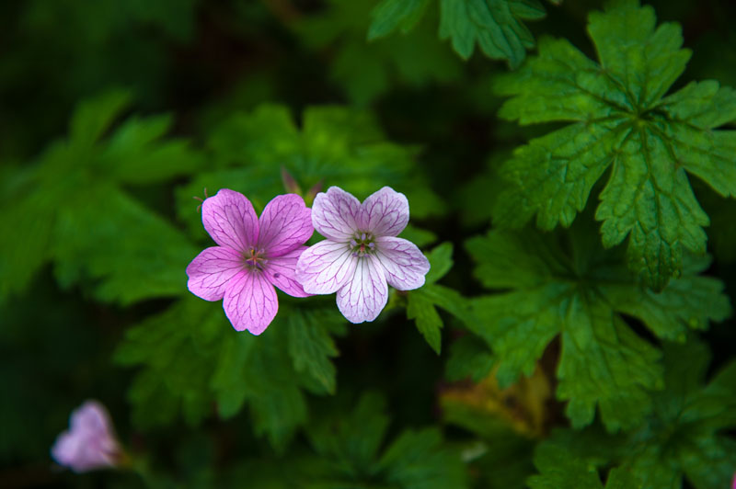
Original picture
Picture contrast is -0.5

