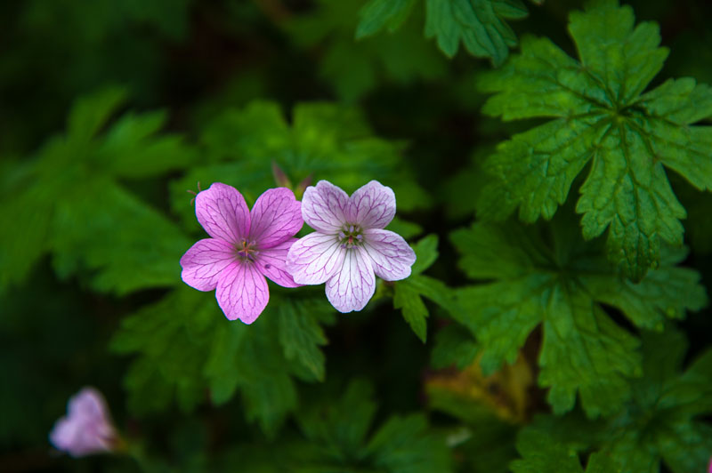
Original picture
Picture brightness is 0.5

